**\*LoG_gray.cpp\***

**1. Code explanation**

1) overall explanation

: 흑백 이미지의 Laplacian of Gaussian 을 출력한다. Gaussian 과 Laplacian kernel을 구하는 함수, 각 filtering의 결과를 구하는 함수, boundary processing을 위한 mirroring 함수를 정의하고 있다.

2) code

int main() {

Mat input = imread("C:\\Users\\MIN\\Desktop\\권민서\\학교\\2022-1\\오소프\\Lab07\\lena.jpg", CV_LOAD_IMAGE_COLOR);

Mat input_gray;

// check for validation

if (!input.data) {

printf("Could not open\n"); return -1;

}

//Gaussian smoothing parameters

int window_radius = 2; double sigma_t = 2.0; double sigma_s = 2.0;

cvtColor(input, input_gray, CV_RGB2GRAY); // convert RGB to Grayscale

//convert input_gray into : input_gray*alpha + beta (alpha=1.0/255 , beta= 0.0

input_gray.convertTo(input_gray, CV_64F, 1.0 / 255);// 8-bit unsigned char -> 64-bit floating point

Mat h_f = Gaussianfilter(input_gray, window_radius, sigma_t, sigma_s);//h(x,y)*f(x,y)

Mat Laplacian = Laplacianfilter(h_f);

//0: 변환 최소값, 1: 변환 최대값, CV_MINMAX: 변환 방식

//Laplacain matrix를 0과 1 사이 값으로 normalize 한다

normalize(Laplacian, Laplacian, 0, 1, CV_MINMAX);

namedWindow("Grayscale", WINDOW_AUTOSIZE);

imshow("Grayscale", input_gray);

namedWindow("Gaussian blur", WINDOW_AUTOSIZE);

imshow("Gaussian blur", h_f);

//Laplacina matrix의 값들을 0과 255사이 값들로 변환해준다

Laplacian.convertTo(Laplacian, CV_8U, 255.0);

namedWindow("Laplacian filter", WINDOW_AUTOSIZE);

imshow("Laplacian filter", Laplacian);

waitKey(0);

return 0;

}

//gaussian filtering function

//input: input intensity matrix, n: kernel size is (2n+1)*(2n+1), sigma_t / sigma_s: standard deviation

Mat Gaussianfilter(const Mat input, int n, double sigma_t, double sigma_s) {

int row = input.rows;

int col = input.cols;

// generate gaussian kernel

Mat kernel = get_Gaussian_Kernel(n, sigma_t, sigma_s, true);

Mat output = Mat::zeros(row, col, input.type());

//Intermediate data generation for mirroring

Mat input_mirror = Mirroring(input, n);

for (int i = n; i < row + n; i++) {

for (int j = n; j < col + n; j++) {

double sum1 = 0.0;

for (int a = -n; a <= n; a++) { // for each kernel window

for (int b = -n; b <= n; b++) {

sum1 += input_mirror.at<double>(i + a, j + b) * kernel.at<double>(a + n, b + n);

}

}

output.at<double>(i - n, j - n) = sum1;

}

}

return output;

}

//laplacian filter function

//'input' will be gaussian smoothed image

Mat Laplacianfilter(const Mat input) {

int row = input.rows;

int col = input.cols;

Mat kernel = get_Laplacian_Kernel();

Mat output = Mat::zeros(row, col, input.type());

int n = 1; //because laplacian kernel is 3x3 size

Mat input_mirror = Mirroring(input, n);

for (int i = n; i < row + n; i++) {

for (int j = n; j < col + n; j++) {

double sum1 = 0.0;

for (int a = -n; a <= n; a++) { // for each kernel window

for (int b = -n; b <= n; b++) {

sum1 += input_mirror.at<double>(i + a, j + b) * kernel.at<double>(a + n, b + n);

}

}

output.at<double>(i - n, j - n) = sum1;

}

}

return output;

}

3) analysis & explanation of the code

1. Grayscale 이미지를 convertTo 함수를 이용하여 64-bit unsigned char 타입으로 변환시키고 alpha=1.0/255값을 곱한다.
2. Gaussianfilter 함수를 이용하여 gaussian smoothing이 이루어진 이미지를 h_f에 저장한다. filtering시에는 mirroring 함수를 이용해 boundary processing을 한다.
3. Laplacianfilter를 이용하여 h_f의 Laplacian filtering 결과, 즉 grayscale 이미지의 LoG를 구한다. filtering시에는 mirroring 함수를 이용해 boundary processing을 한다. Laplacian kernel이 3x3 사이즈이므로 mirroring시의 window radius는 1이다.

**2. Results & analysis and explanation**

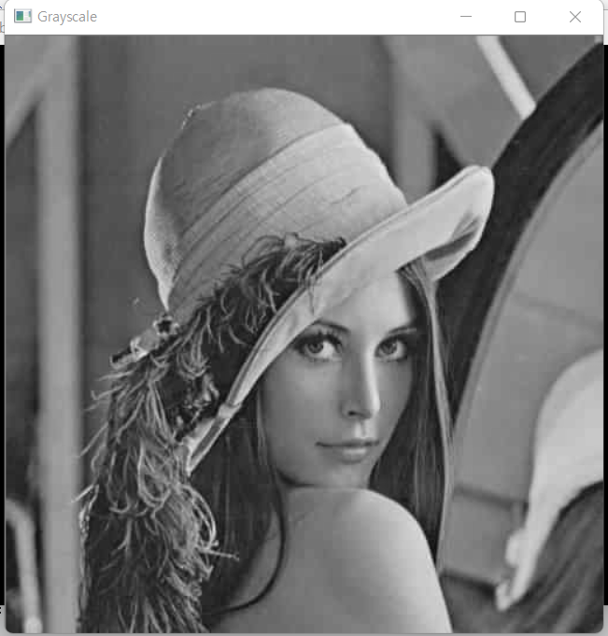 original image

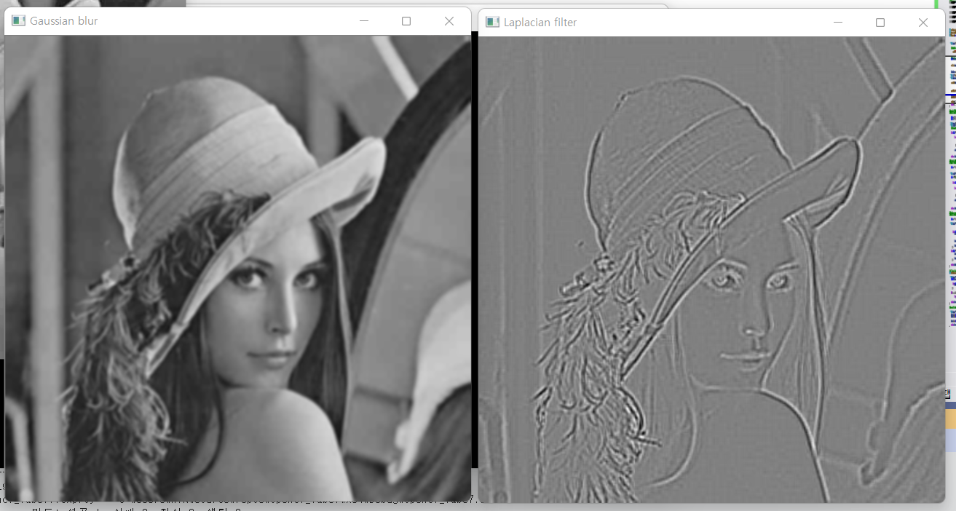

Gaussian smoothed image(n=2, sigma_t=2.0, sigma_s=2.0, mirroring) / Laplacian of gaussian

**\*LoG_RGB.cpp\***

**1. Code explanation**

1) overall explanation

컬러 이미지의 Laplacian of Gaussian을 출력한다. Gaussian 과 Laplacian kernel을 구하는 함수, 각 filtering의 결과를 구하는 함수, boundary processing을 위한 mirroring 함수를 정의하고 있다.

2) code

int main() {

Mat input = imread("C:\\Users\\MIN\\Desktop\\권민서\\학교\\2022-1\\오소프\\Lab07\\lena.jpg", CV_LOAD_IMAGE_COLOR);

// check for validation

if (!input.data) {

printf("Could not open\n"); return -1;

}

//Gaussian smoothing parameters

int window_radius = 2;

double sigma_t = 2.0; double sigma_s = 2.0;

//convert input_gray into : input_gray*alpha + beta

//alpha=1.0/255 , beta= 0.0(default parameter)

input.convertTo(input, CV_64FC3, 1.0 / 255); // 8-bit unsigned char -> 64-bit floating point

Mat h_f = Gaussianfilter(input, window_radius, sigma_t, sigma_s); // h(x,y) * f(x,y)

Mat Laplacian = Laplacianfilter(h_f);

//0: 변환 최소값, 1: 변환 최대값, CV_MINMAX: 변환 방식

//Laplacain matrix를 0과 1 사이 값으로 normalize 한다

normalize(Laplacian, Laplacian, 0, 1, CV_MINMAX);

namedWindow("Original", WINDOW_AUTOSIZE);

imshow("Original", input);

namedWindow("Gaussian blur", WINDOW_AUTOSIZE);

imshow("Gaussian blur", h_f);

//Laplacina matrix의 값들을 0과 255사이 값들로 변환해준다

Laplacian.convertTo(Laplacian, CV_8UC3, 255.0);

namedWindow("Laplacian filter", WINDOW_AUTOSIZE);

imshow("Laplacian filter", Laplacian);

waitKey(0);

return 0;

}

//gaussian filtering function

//input: input intensity matrix, n: kernel size is (2n+1)*(2n+1), sigma_t / sigma_s: standard deviation

Mat Gaussianfilter(const Mat input, int n, double sigma_t, double sigma_s) {

int row = input.rows; int col = input.cols;

// generate gaussian kernel

Mat kernel = get_Gaussian_Kernel(n, sigma_t, sigma_s, true);

Mat output = Mat::zeros(row, col, input.type());

//Intermediate data generation for mirroring

Mat input_mirror = Mirroring(input, n);

for (int i = n; i < row + n; i++) {

for (int j = n; j < col + n; j++) {

//intensity value of each channel

double sum1_r = 0.0; double sum1_g = 0.0; double sum1_b = 0.0;

for (int a = -n; a <= n; a++) { // for each kernel window

for (int b = -n; b <= n; b++) {

sum1_r += input_mirror.at<Vec3d>(i + a, j + b)[0] * kernel.at<double>(a + n, b + n);

sum1_g += input_mirror.at<Vec3d>(i + a, j + b)[1] * kernel.at<double>(a + n, b + n);

sum1_b += input_mirror.at<Vec3d>(i + a, j + b)[2] * kernel.at<double>(a + n, b + n);

}

}

output.at<Vec3d>(i - n, j - n)[0] = sum1_r;

output.at<Vec3d>(i - n, j - n)[1] = sum1_g;

output.at<Vec3d>(i - n, j - n)[2] = sum1_b;

}

}

return output;

}

//laplacian filter function

//'input' will be gaussian smoothed image

Mat Laplacianfilter(const Mat input) {

int row = input.rows;

int col = input.cols;

Mat kernel = get_Laplacian_Kernel();

Mat output = Mat::zeros(row, col, input.type());

int n = 1; //because laplacian kernel is 3x3 size

Mat input_mirror = Mirroring(input, n);

for (int i = n; i < row + n; i++) {

for (int j = n; j < col + n; j++) {

double sum1_r = 0.0; //intensity value of each channel

double sum1_g = 0.0;

double sum1_b = 0.0;

for (int a = -n; a <= n; a++) { // for each kernel window

for (int b = -n; b <= n; b++) {

sum1_r += input_mirror.at<Vec3d>(i + a, j + b)[0] * kernel.at<double>(a + n, b + n);

sum1_g += input_mirror.at<Vec3d>(i + a, j + b)[1] * kernel.at<double>(a + n, b + n);

sum1_b += input_mirror.at<Vec3d>(i + a, j + b)[2] * kernel.at<double>(a + n, b + n);

}

}

output.at<Vec3d>(i - n, j - n)[0] = (double)max(sum1_r, max(sum1_g, sum1_b));

output.at<Vec3d>(i - n, j - n)[1] = (double)max(sum1_r, max(sum1_g, sum1_b));

output.at<Vec3d>(i - n, j - n)[2] = (double)max(sum1_r, max(sum1_g, sum1_b));

}

}

return output;

}

//boundary processing method is fixed with mirroring

//input: intensity matrix of image, n: window radius

Mat Mirroring(const Mat input, int n)

{

int row = input.rows;

int col = input.cols;

Mat input2 = Mat::zeros(row + 2 * n, col + 2 * n, input.type()); //fixed image

int row2 = input2.rows;

int col2 = input2.cols;

//3 channel image-> Vec3d type

for (int i = n; i < row + n; i++) {

for (int j = n; j < col + n; j++) {

input2.at<Vec3d>(i, j) = input.at<Vec3d>(i - n, j - n);

}

}

for (int i = n; i < row + n; i++) {

for (int j = 0; j < n; j++) {

input2.at<Vec3d>(i, j) = input2.at<Vec3d>(i, 2 * n - j);

}

for (int j = col + n; j < col2; j++) {

input2.at<Vec3d>(i, j) = input2.at<Vec3d>(i, 2 * col - 2 + 2 * n - j);

}

}

for (int j = 0; j < col2; j++) {

for (int i = 0; i < n; i++) {

input2.at<Vec3d>(i, j) = input2.at<Vec3d>(2 * n - i, j);

}

for (int i = row + n; i < row2; i++) {

input2.at<Vec3d>(i, j) = input2.at<Vec3d>(2 * row - 2 + 2 * n - i, j);

}

}

return input2;

}

3) analysis & explanation of the code

1. Grayscale 이미지를 convertTo 함수를 이용하여 64-bit unsigned char channel 3 타입으로 변환시키고 alpha=1.0/255값을 곱한다.
2. Gaussianfilter 함수를 이용하여 gaussian smoothing이 이루어진 이미지를 h_f에 저장한다. filtering시에는 mirroring 함수를 이용해 boundary processing을 하고, 3개의 각 채널에 대해 filtering 연산을 한 뒤 값을 저장한다.
3. Laplacianfilter를 이용하여 h_f의 Laplacian filtering 결과, 즉 grayscale 이미지의 LoG를 구한다. R, G, B 각 채널의 filtering 결과를 sum1_r, sum1_g, sum1_b에 저장한 뒤 이 중 최댓값을 output matrix에 저장한다. 그리고 filtering시에는 mirroring 함수를 이용해 boundary processing을 하고, Laplacian kernel이 3x3 사이즈이므로 mirroring시의 window radius는 1이다.

**2. Results & analysis and explanation**

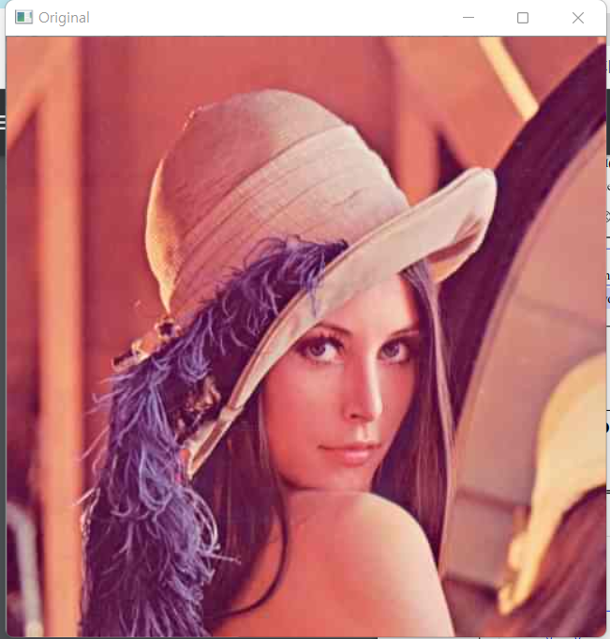 Original RGB image

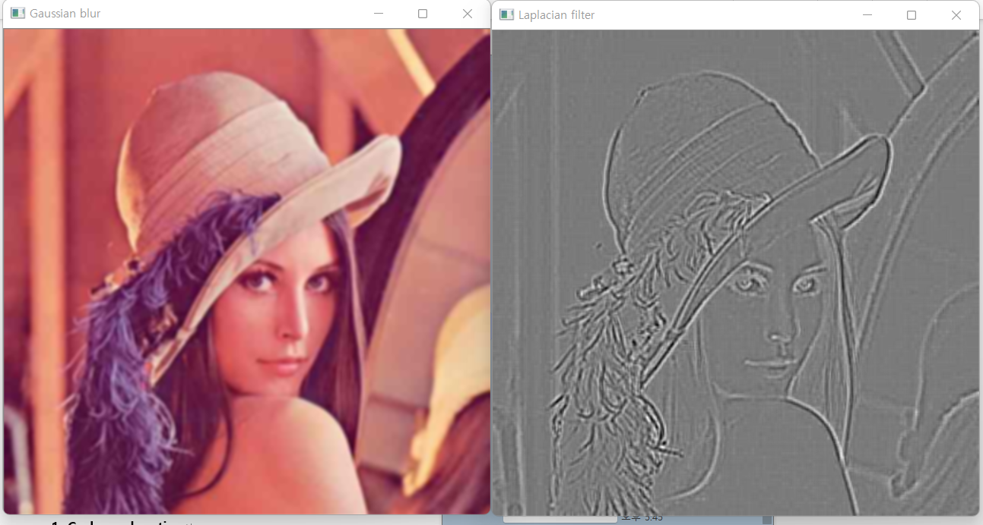

Gaussian smoothed image(n=2, sigma_t=2.0, sigma_s=2.0, mirroring) / Laplacian of gaussian

**\*Canny.cpp\***

**1. Code explanation**

1) overall explanation

: Canny.cpp는 Canny 함수를 사용하여 “lean.jpg”의 canny edge detected image를 구한다.

2) code

#include <opencv2/opencv.hpp>

#include "opencv2/highgui.hpp"

#include <iostream>

using namespace cv;

int main() {

Mat input = imread("C:\\Users\\MIN\\Desktop\\권민서\\학교\\2022-1\\오소프\\Lab07\\lena.jpg", CV_LOAD_IMAGE_COLOR);

Mat input_gray, output;

// check for validation

if (!input.data) {

printf("Could not open\n");

return -1;

}

cvtColor(input, input_gray, CV_RGB2GRAY); // convert RGB to Grayscale

input_gray.convertTo(input_gray, CV_8U); //input must be 8 bit image

//Fill the code using 'Canny' in OpenCV.

Canny(input_gray, output, 50, 95, 3, true);

namedWindow("Grayscale", WINDOW_AUTOSIZE);

imshow("Grayscale", input_gray);

output.convertTo(output, CV_8U);

namedWindow("Canny", WINDOW_AUTOSIZE);

imshow("Canny", output);

waitKey(0);

return 0;

}

3) analysis & explanation of the code

OpenCV function인 Canny function을 이용해 Canny edge detection을 실행한다.

void Canny(InputArray image, OutputArray edges, double threshold1, double threshold2, int apertureSize = 3, bool L2gradient = false )

1. Perform noise reduction using Sobel filter. Sobel filter kernel window size는 parameter인 apertureSize로 결정된다.
2. Compute magnitude and angle of Gaussian smoothened image with Sobel filter

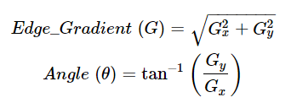

1. Perform non-maximum suppression in the gradient direction
2. Double thresholding (threshold will be two parameters ‘threshold1’, and ‘threshold2’)

**2. Results & analysis and explanation**

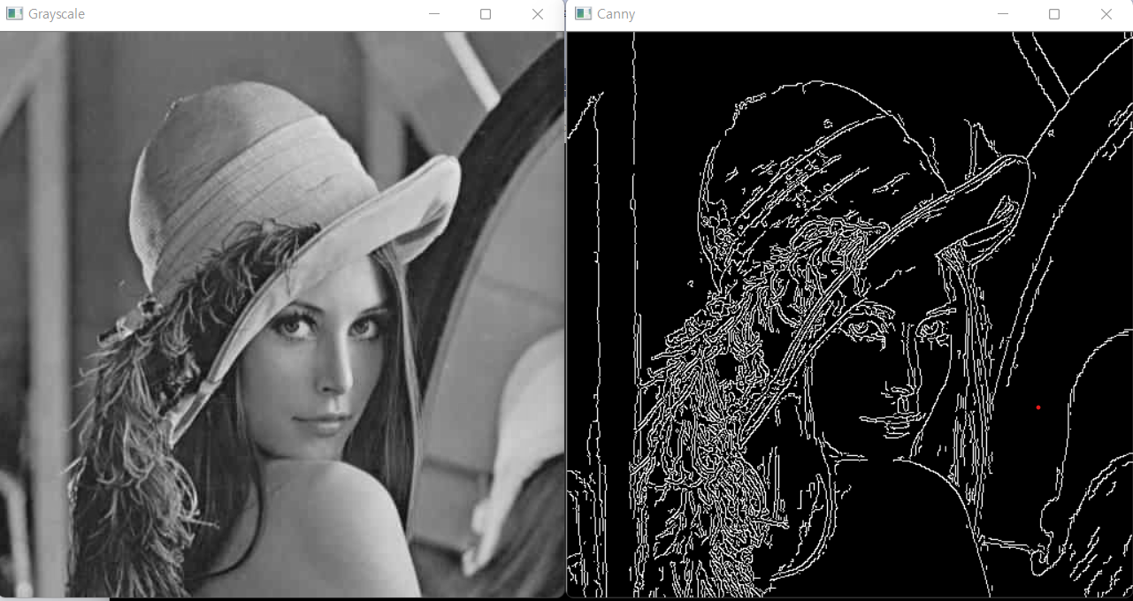

Threshold1=50, threshold=95, aperture=3, L2gradient=flase

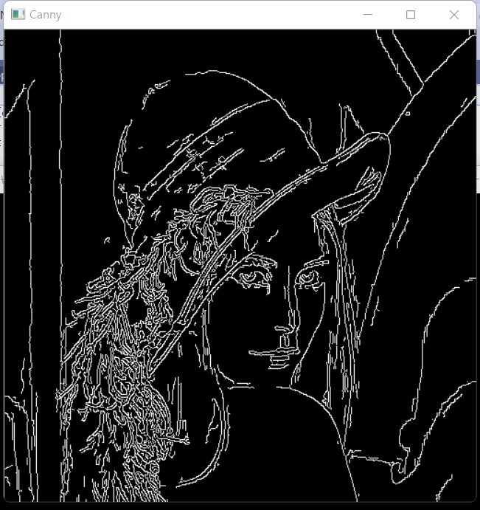

threshold1=50, threshold2=95, aperture=3, L2gradient=true

**\*Harris_corner.cpp\***

**1. Code explanation**

1) overall explanation

: Harris_corner.cpp는 주어진 이미지를 cornerHarris() 함수를 이용해 Harris response map를 출력하고, threshold 보다 큰 corner들을 circle() 함수를 이용해 이미지에 표시한다. 그 후, non-maximum suppression과 sub-pixel refinement의 option이 true인 경우 이 과정을 거친 이미지를 각각 출력한다.

2) code

//Harris corner detection using 'cornerHarris'

//Note that 'src' of 'cornerHarris' can be either 1) input single-channel 8-bit or 2) floating-point image.

int blockSize = 2;

int apertureSize = 3;

double k = 0.04;

input_gray.convertTo(input_gray, CV_32FC1, 1.0/255);

cornerHarris(input_gray, output, blockSize, apertureSize, k, BORDER_DEFAULT);

//Sub-pixel refinement for detected corners

if (Subpixel)

{

Size subPixWinSize(3, 3); //sub-pixel window size is 7x7

TermCriteria termcrit(TermCriteria::COUNT | TermCriteria::EPS, 20, 0.03);

points = MatToVec(corner_mat);

output.convertTo(output, CV_8UC1);

cornerSubPix(output, points, subPixWinSize, Size(-1, -1), termcrit);

//Display the set of corners

input_visual = input.clone();

for (int k = 0; k < points.size(); k++) {

int x = points[k].x; int y = points[k].y;

if (x<0 || x>col - 1 || y<0 || y>row - 1) //corner들이 image 영역 바깥에 있는 경우

{

points.pop_back();

continue;

}

circle(input_visual, Point(x, y), 2, Scalar(0, 0, 255), 1, 8, 0);

}

printf("After subpixel-refinement, corner number = %d\n\n", points.size());

namedWindow("Harris Corner (subpixel)", WINDOW_AUTOSIZE);

imshow("Harris Corner (subpixel)", input_visual);

}

Mat NonMaximum_Suppression(const Mat input, Mat corner_mat, int radius)

{

int row = input.rows;

int col = input.cols;

Mat input_mirror = Mirroring(input, radius); //use mirroring method for boundary processing

for (int i = radius; i < row + radius; i++) {

for (int j = radius; j < col + radius; j++) {

if (corner_mat.at<uchar>(i - radius, j - radius) == 1) {

double max = 0.0;

for (int a = -radius; a <= radius; a++) { // for each window

for (int b = -radius; b <= radius; b++) {

if (input_mirror.at<float>(i + a, j + b) > max) max = input_mirror.at<float>(i + a, j + b);

}

}

if (max == input_mirror.at<float>(i, j))

corner_mat.at<uchar>(i - radius, j - radius) = 1;

else

corner_mat.at<uchar>(i - radius, j - radius) = 0;

}

}

}

return input;

}

3) analysis & explanation of the code

1. Compute M matrix

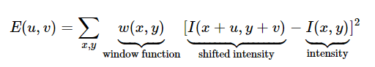

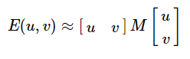 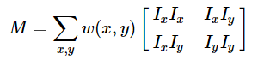

Second moment matrix인 M은 위와 같은 과정을 거쳐서 구할 수 있다. (Ix, Iy are x, y direction image derivatives which can be found by Sobel filtering)

1. Compute corner response R and find points with large corner response. (R > threshold)

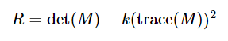

det(M)= $λ_{1}$ + $λ_{2}$, trace(M)= $λ_{1}λ_{2}$ ( $λ_{1}$ and $λ_{2}$ are eigenvalues of M)

1. Through 2D non-maximum suppression, take only points which are local maxima.
2. Through sub-pixel refinement, adjust the corner locations with sub pixel accuracy.

**2. Results & analysis and explanation**

1) checkerboard.png

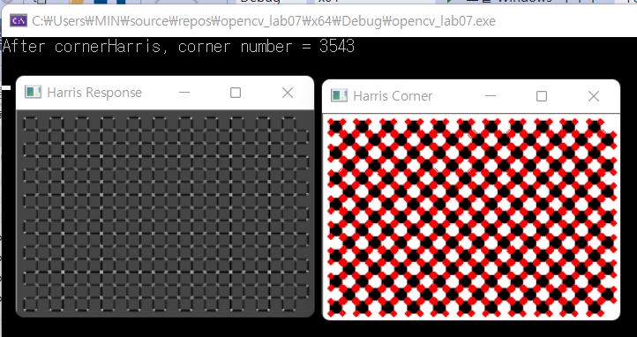

NonMaxSupp = false, Subpixel = false

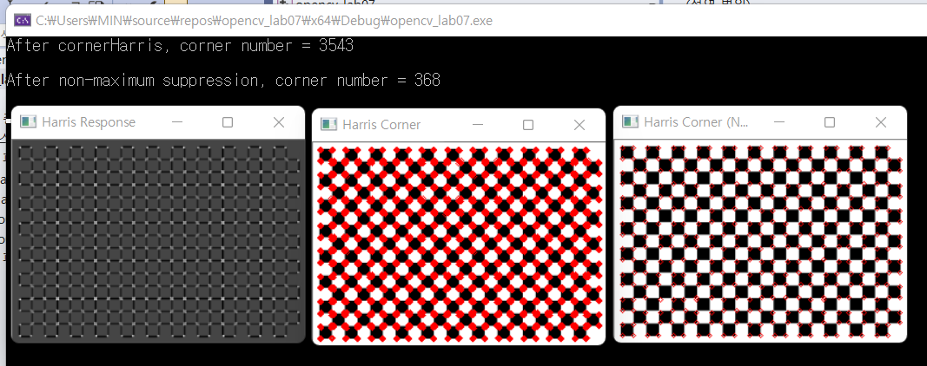

NonMaxSupp = true, Subpixel = false

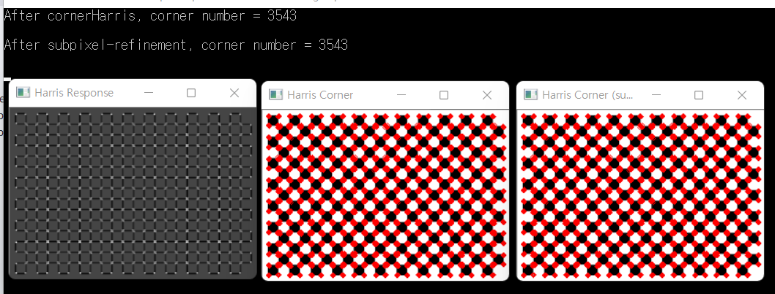

NonMaxSupp = false, Subpixel = true

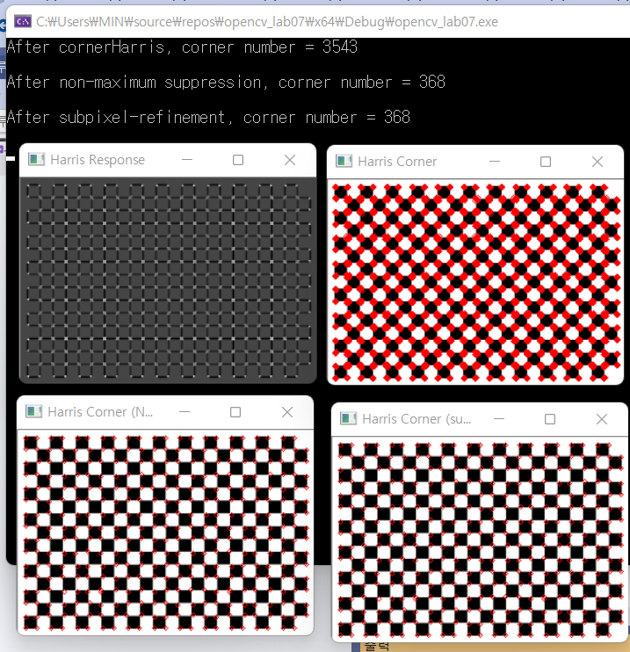

NonMaxSupp = true, Subpixel = true

2) checkerboard2.jpg

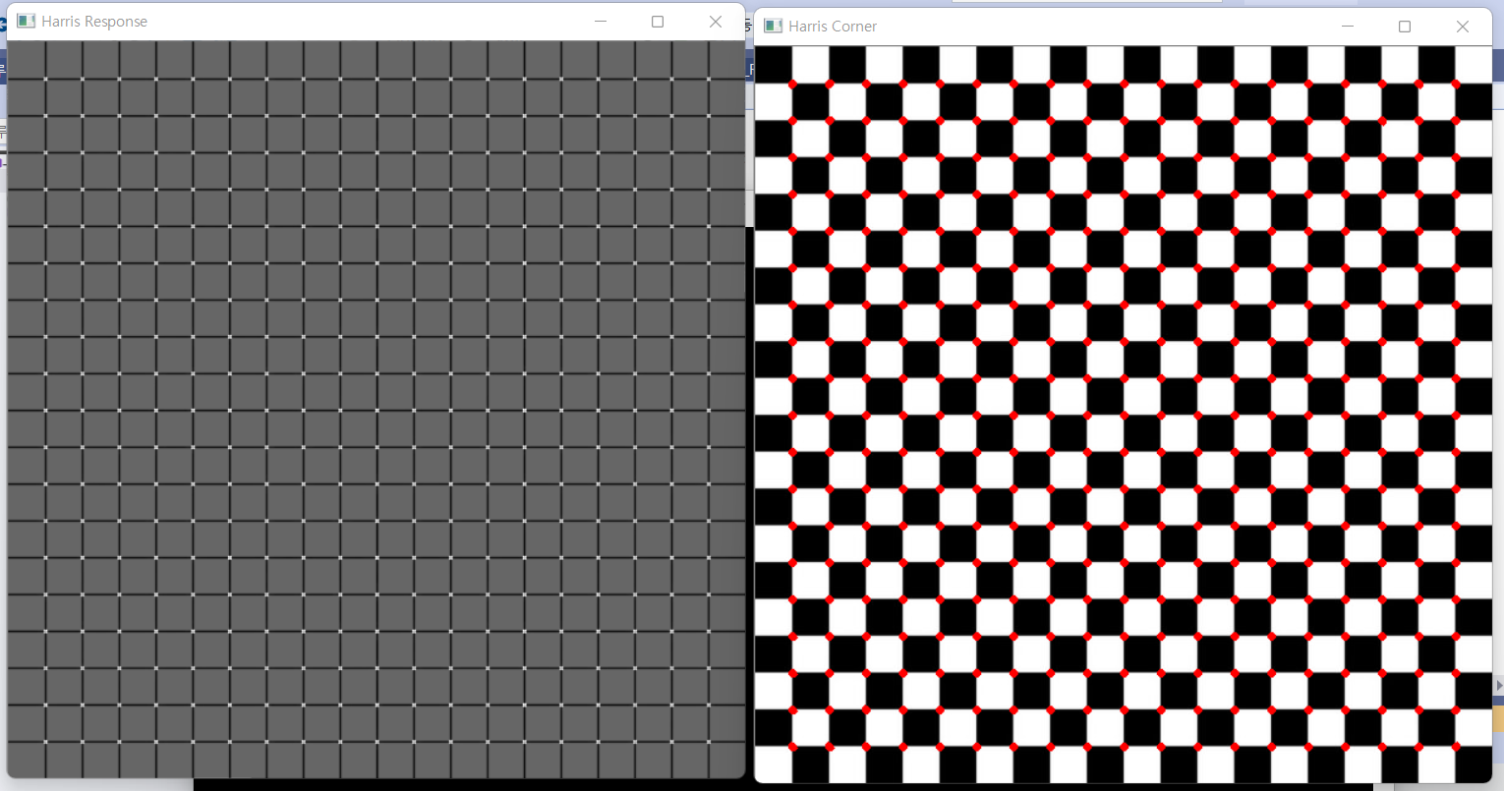

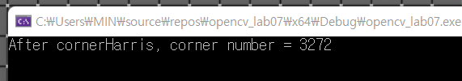

NonMaxSupp = false, Subpixel = false

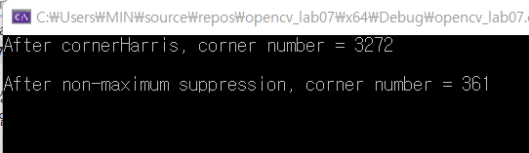

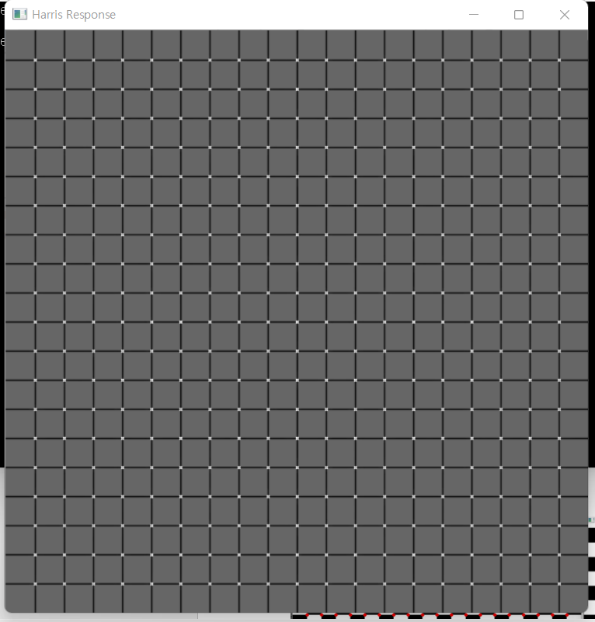

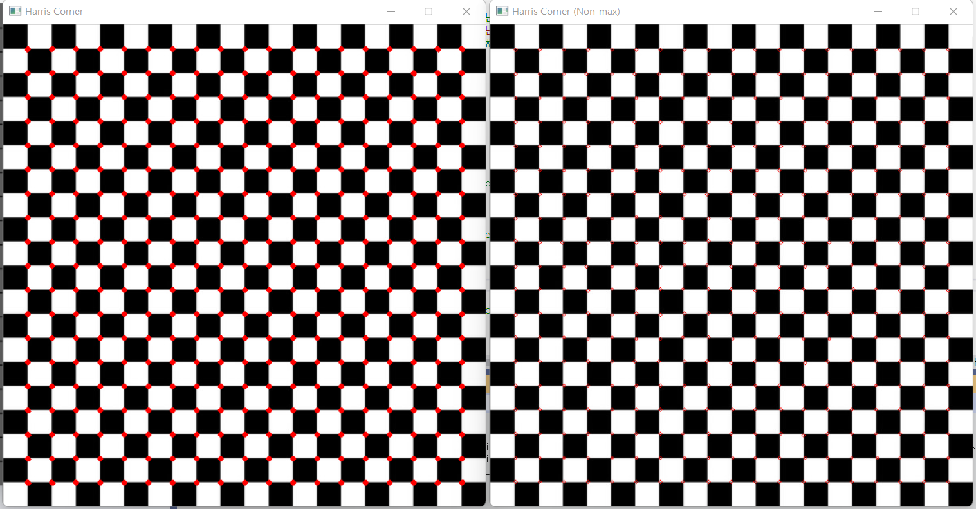

NonMaxSupp = true, Subpixel = false

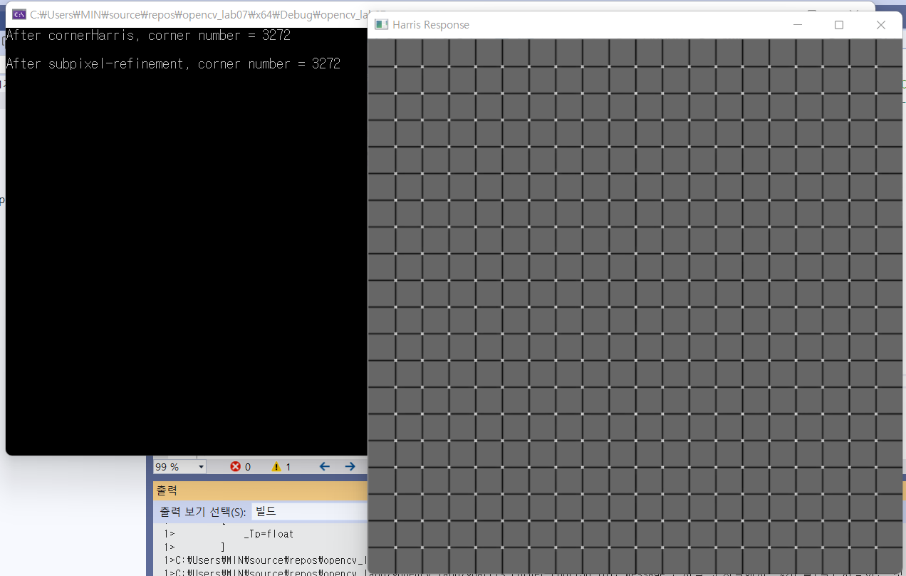

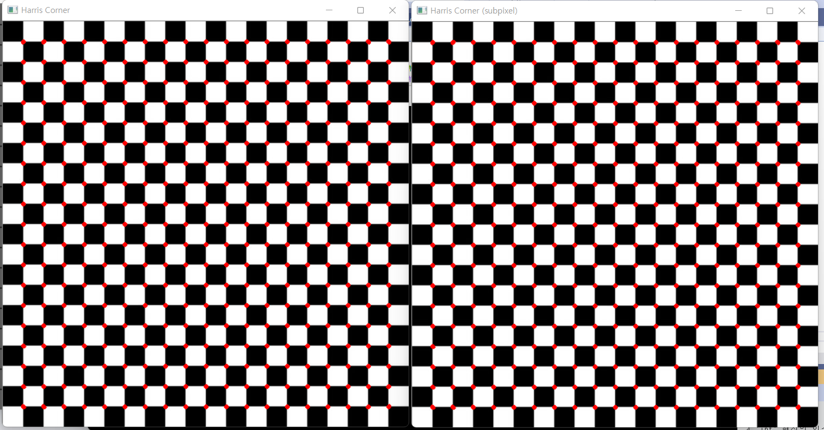

NonMaxSupp = false, Subpixel = true

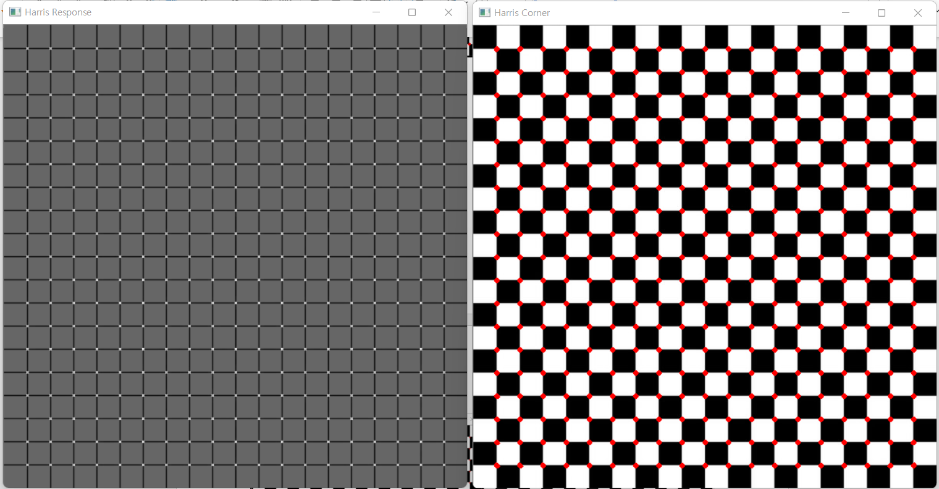

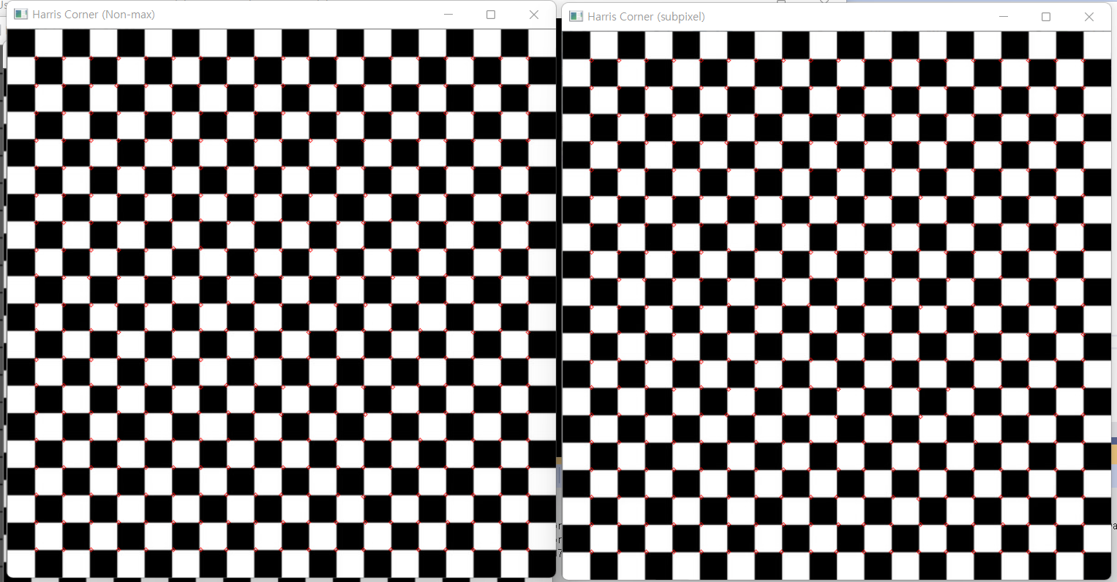

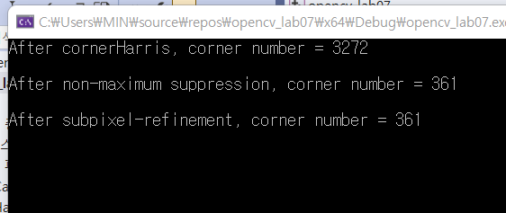

NonMaxSupp = true, Subpixel = true

3) lena.jpg

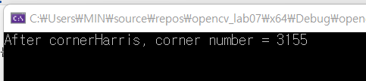

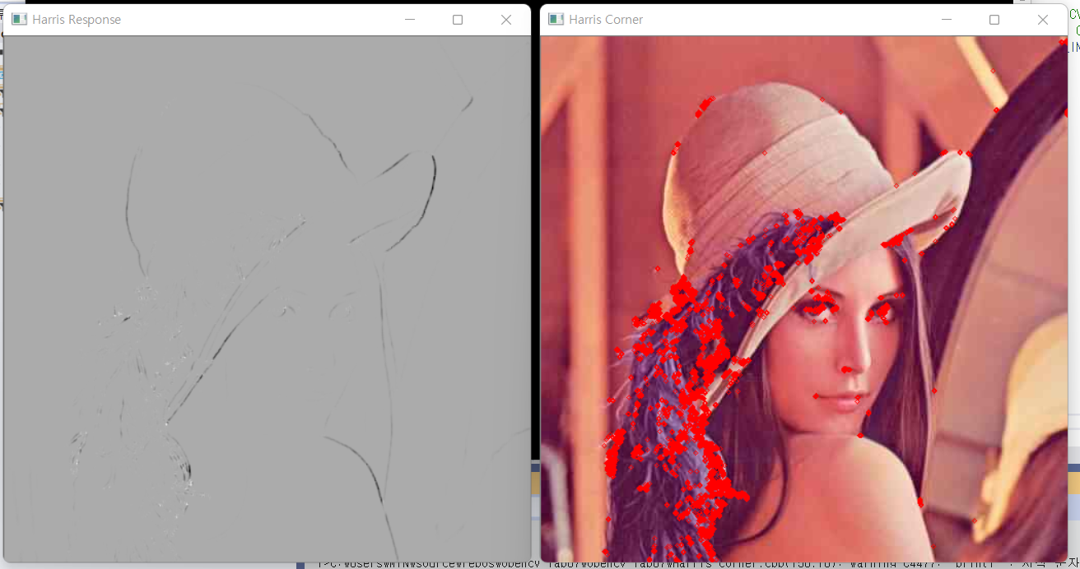

NonMaxSupp = false, Subpixel = false

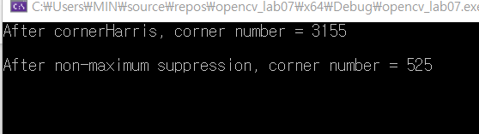



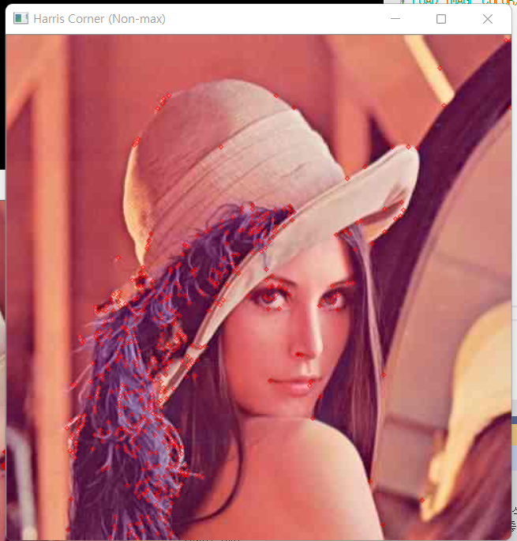

NonMaxSupp = true, Subpixel = false

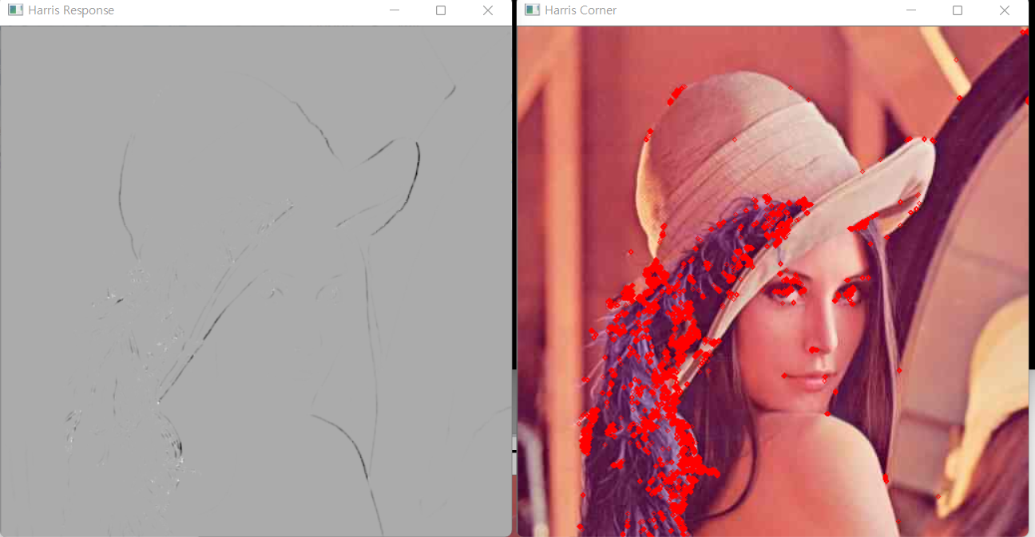

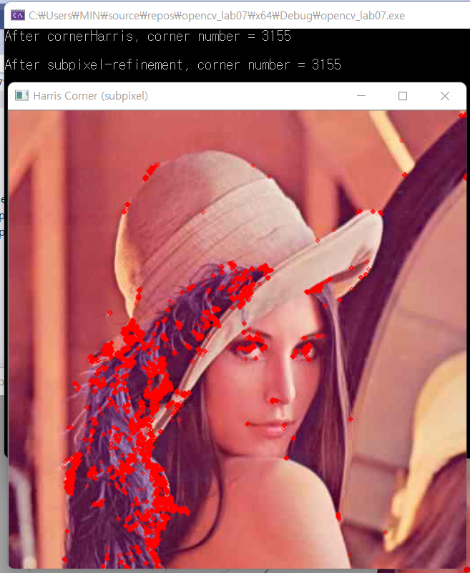

NonMaxSupp = false, Subpixel = true

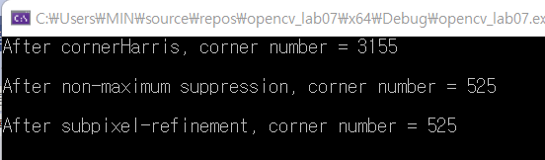



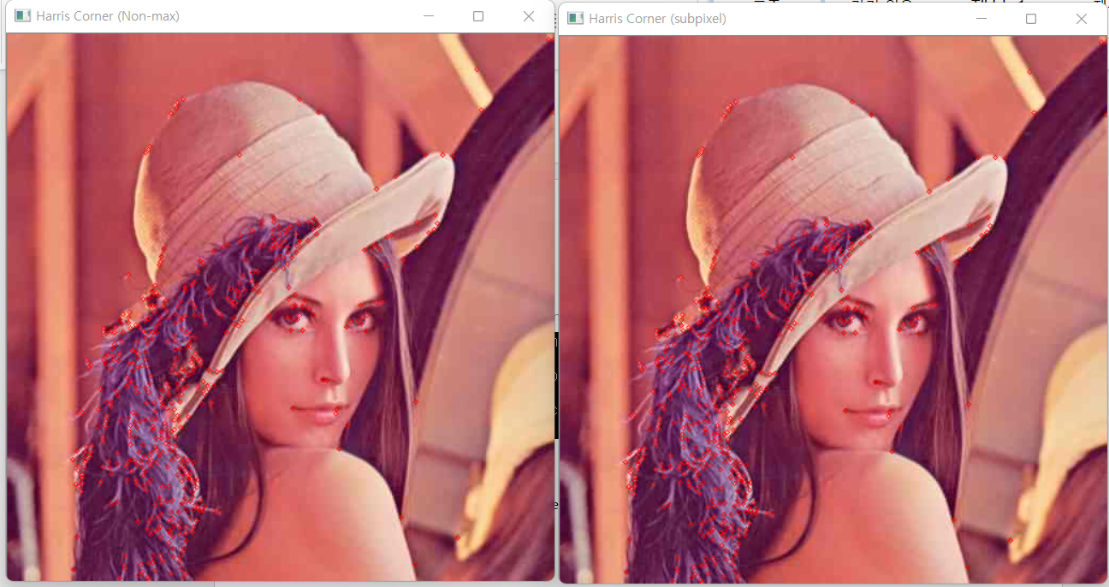

NonMaxSupp = true, Subpixel = true

위 결과를 통해 nom-maximum suppression을 거치면 corner의 수가 줄어든다는 것을 알 수 있다.